**Chapter IV**

**RESULTS AND DISCUSSION**

This chapter summarized the results of the finished system and the data that was collected. This includes the overview of the system created i.e, the description of the device, flowchart, block diagram, hardware components and important materials and parts that will be used in the development of the device.

**SYSTEM OVERVIEW**

Cycling can be risky, specifically when the cyclist is hard to see by other road users or understands their signals by using their hands. That’s why it is important to have a device to improve the safety of the cyclist. The researchers developed the Signal Lights Vest using voice command which is a device that will help the cyclist to communicate with other road users without using hand signals, improve visibility on the road, and avoid the risk of accidents.

The device will use a MEMS microphone to be able to get the voice command of the user. The researchers used machine learning to create a model for voice command recognition and convert it into C++ code. These voice commands will be limited only to the cyclist’s signals such as turn signal lights, brake lights, and slowing down lights. The signal lights will activate when the user starts a command on the microphone. The LED signal lights are incorporated to the vest and it can be detached. When the user says “left” the LED lights will display a blinking left signal and indicate that the user will go left, same as when it says “right” it will display a blinking right signal, and “stop” will display a full red as brake signal and “slow” will display a blinking arrow down/slow down signal.

The device may be used by the cyclist to be able to communicate with other road users without using hand signals and improve visibility on the road. Also, it can be used both during the day and at night, and it is detachable from the vest, allowing the vest to be washed.

**TECHNICAL DESCRIPTION**

This section focuses on the technical details of the system as well as the researchers' activities, in line with the research approach described in the previous chapter. This section also covers the system designs and components that helped the researchers in achieving the objectives of the research.

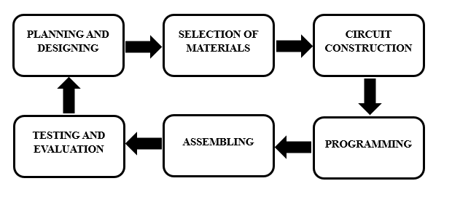

Fig.6  Project Development Cycle

**Planning and Designing**

The researchers completed these tasks as part of the system planning and design. The researchers collected reliable data and created detailed diagrams and charts that explained the system, including its capabilities and limitations. They planned to create a system where the user starts the specific commands, then, the commands have equivalent signals such as left, right, stop, and slow down signals. These signals will be displayed using LED lights and the device is attached to the vest.

To create the system, the researchers followed the steps in the project development cycle. The researchers begin with collecting data by reading different studies of existing devices in order to examine all the factors that must be taken into consideration when designing the signal lights vest. Following the analysis, they create a list of the most appropriate components for the device based on price, quality, quantity, and usefulness. The researchers developed a program that enables the system to function in accordance with the study's objectives.